Time Saving Solutions

# 1)Using external extensions to plot elements in Angular application.

# 2)Collapse or Uncollapse testcases and functions in the WDIO framework, this saves huge manual effort and provides accuracy.

# Problem Statement1:

**It is Time Consuming While locating elements Manually and leads to rework when elements id is not available**

## Solution:

Using this **POM Builder-Auto-generate CSS/XPath Locator Extension**

POM Builder is a powerful browser extension that instantly generates robust web element locators (XPath, CSS selector, ID, Name, etc.) for all test automation frameworks.

You can use these locators for all automation frameworks including Selenium, Protractor, Robot Framework, webdriver.io, Test Architect Enterprise and Test Architect Gondola.

## Advantages:

1. Measurements were performed on long and complex XPath locators.
2. This tool helps us cut down the locator building time by half using a smart pattern-recognition algorithm.
3. And the best part: it’s free.
4. It’s readable and user-friendly.
5. Flexible to use.

## **ReqtID-4247**- FY21 Annual Report update - Part 2 (Review Tool)- Trust- PMR Module. For Above Mentioned CR I have taken More than 120 Elements.

* Manually Effort to collect those elements and check whether it’s working or not—Time taken process is More than 2hrs.
* Plotting All the Elements by using POM Builder Extension –Will take Nearly 30mints with Syntax we can fetch the elements.
* Here We can save the time one and half hour.

## PFB Screenshot’s:

## Installation Process

**1**.Open the extension link on Chrome Web

Store: [**https://chrome.google.com/webstore/detail/pom-builder-auto-generate/akcejfbfkkjnghlfngighgncolfaghco**](https://chrome.google.com/webstore/detail/pom-builder-auto-generate/akcejfbfkkjnghlfngighgncolfaghco)

**2**. Click “Add to Chrome” button

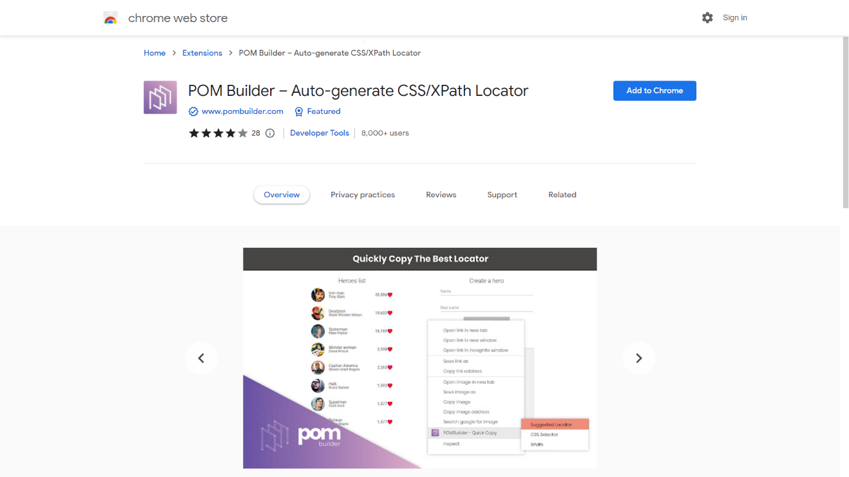

**3**. Click “Add Extension”

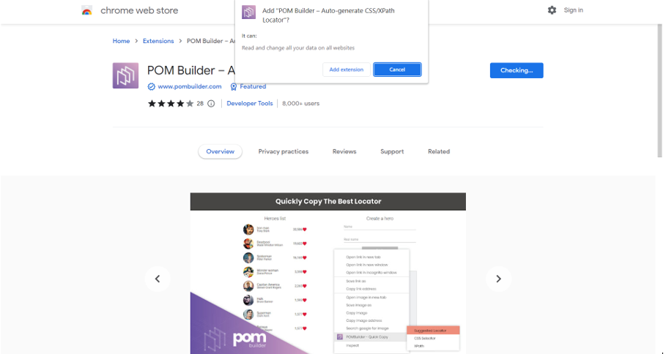

**4**. POM Builder has been installed into your Chrome browser successfully.

### Quick-copy feature

* Right-click on an element of your interest on your webpage under test
* Select “POM Builder — Quick Copy” > <your desired selection>
* There are 3 available selections:
* Suggested Locator: the most reliable locator recommended by POM Builder, you should use it for better performance and stability. It could be a single attribute locator, CSS Selector or XPath locator.
* CSS Selector: the CSS selector that uniquely identifies the selected element
* XPath: the XPath locator that uniquely identifies the selected element

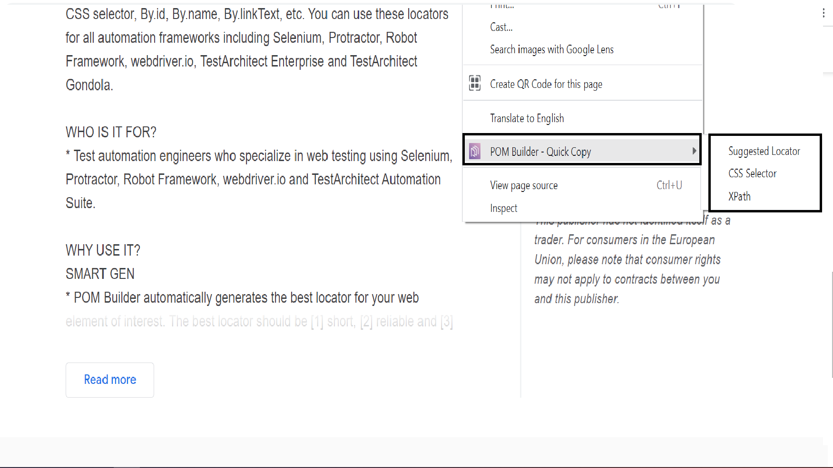

* After selecting your desired selector, the appropriate locator will be saved to clipboard.
* Freely paste it anywhere to use the generated value



### View & test your locator with POM Builder tab

* Right-click on an element on your webpage
* Select Inspect

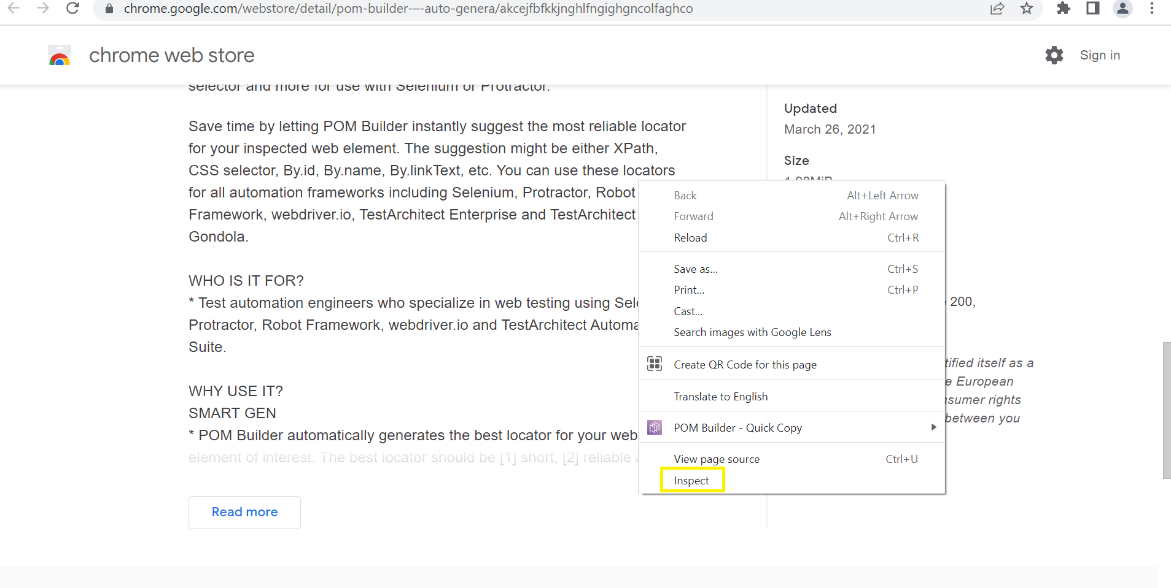

* On the Elements tab, select the POM Builder sub-tab

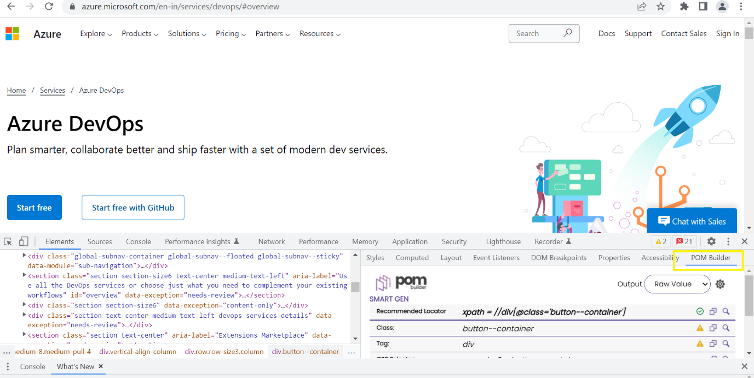

* You can now view a variety of locators that may uniquely identify the selected element on the POM Builder tab.

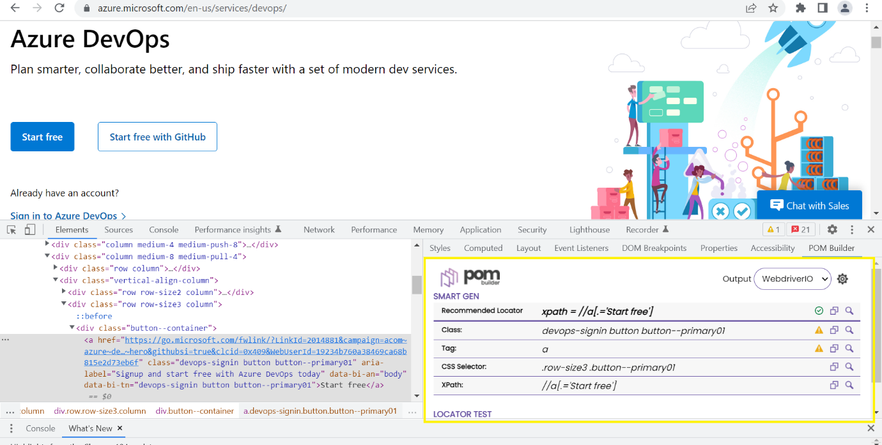

* You can click on an element directly displayed on the DOM tree or use the inspect function to select another element.
* The appropriate locator(s) will be generated on the POM Builder tab
* Click the Copy icon to copy its value

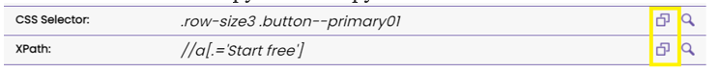

* Click the Find icon to test it with the Test Locator feature



1. You can define your own locator and test it with Test Locator of POM Builder
2. Select the type of locator (XPath/CSS)
3. Type your locator in the search box then hit Enter. Ideally, you’d expect to see that only ONE element that matches the specified locator is found.
4. POM Builder will show the searching result info,
5. how many matching element(s)
6. matching element(s)

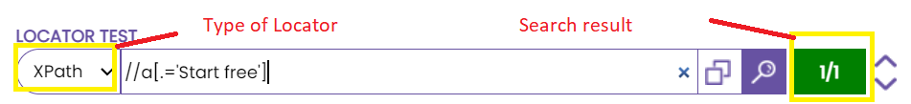

* You can click on arrow button to change matching element and locate it on the webpage and DOM tree
* You can edit your locator and start new search.

# Problem Statement2:

**In Some Modules We Have More than 360 Testcases To collapse each testcase individually- It is Time Consuming Process.**

## Solution:

Using this **Notepad++ Keymap** Extension.

We can fold all the testcases at a time by using **alt+0** and unfold by using **alt+shift+0.**

* **Manually Effort** to collapse 360 testcases is—Time taken process it is consuming around **15mints.**
* By using Notepad++ Keymap **Extension** –Will complete with in **2seconds.**
* Here We can save the time **14mints 58seconds.**

## PFB Screenshot’s:

## Installation Process

**1**.Open Visual Studio Code, Once Visual Studio Code is open.

**2**.To install a **Notepad++ Keymap,** open the extensions search bar by pressing (Ctrl+Shift+X) Or click on extension icon.

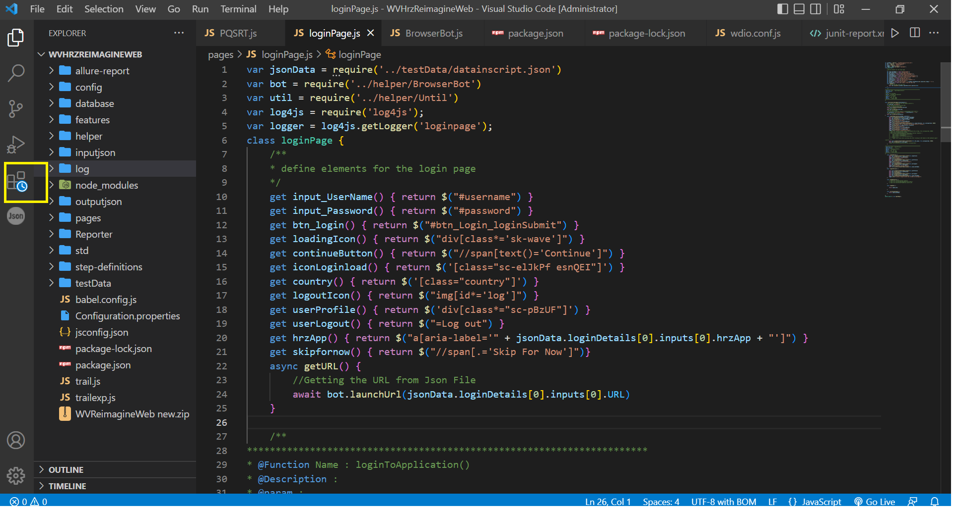

**3**. And your cursor focuses the search bar.

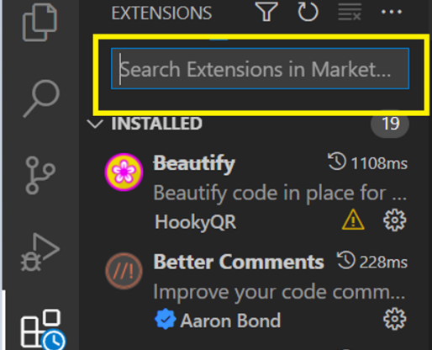

**4**.Then search for “**Notepad++ Keymap**”.

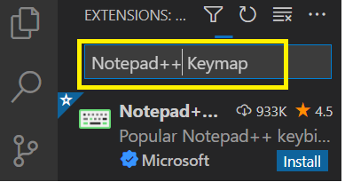

**5**.You see now a “**Notepad++ Keymap**” click on it, will open in a new window.

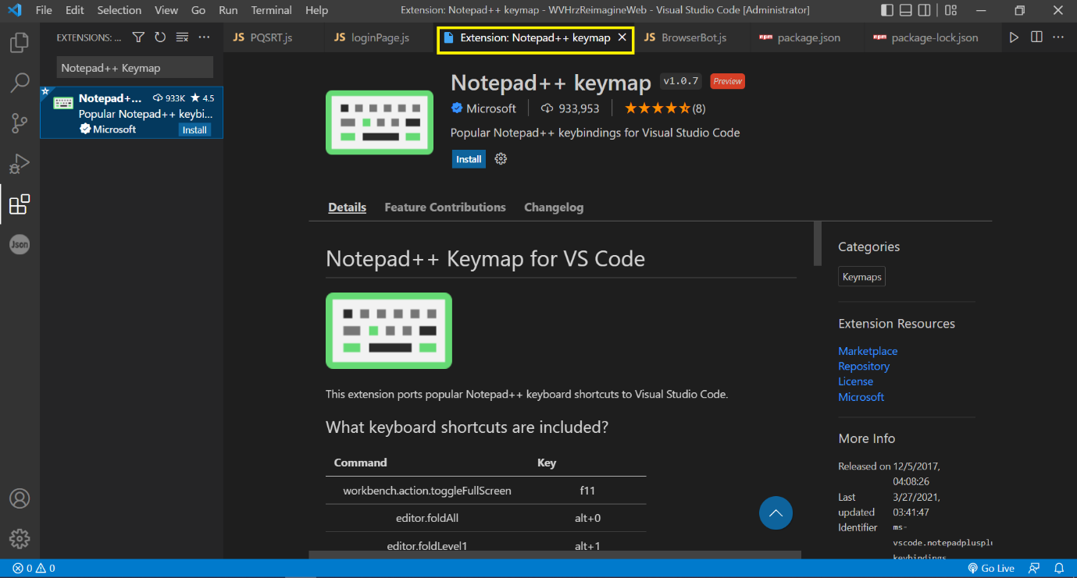

**6**.Click on “Install” button.

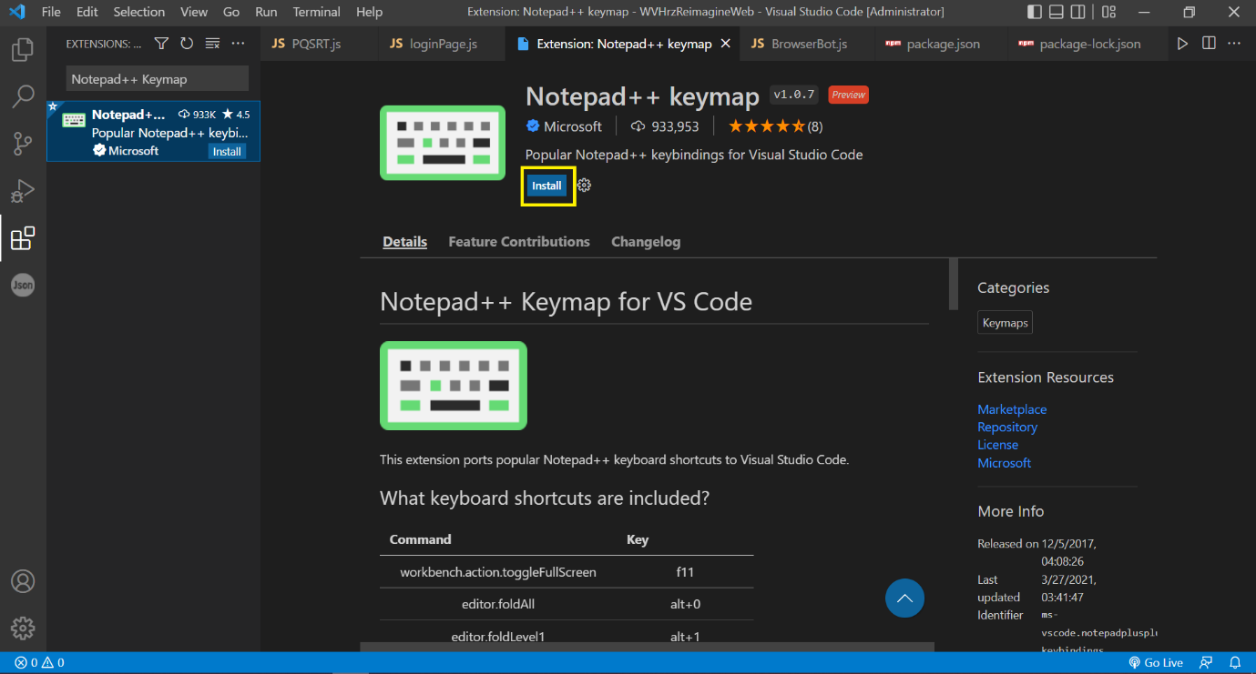

**7**. “**Notepad++ Keymap**” has been installed into your Visual Studio Code successfully.

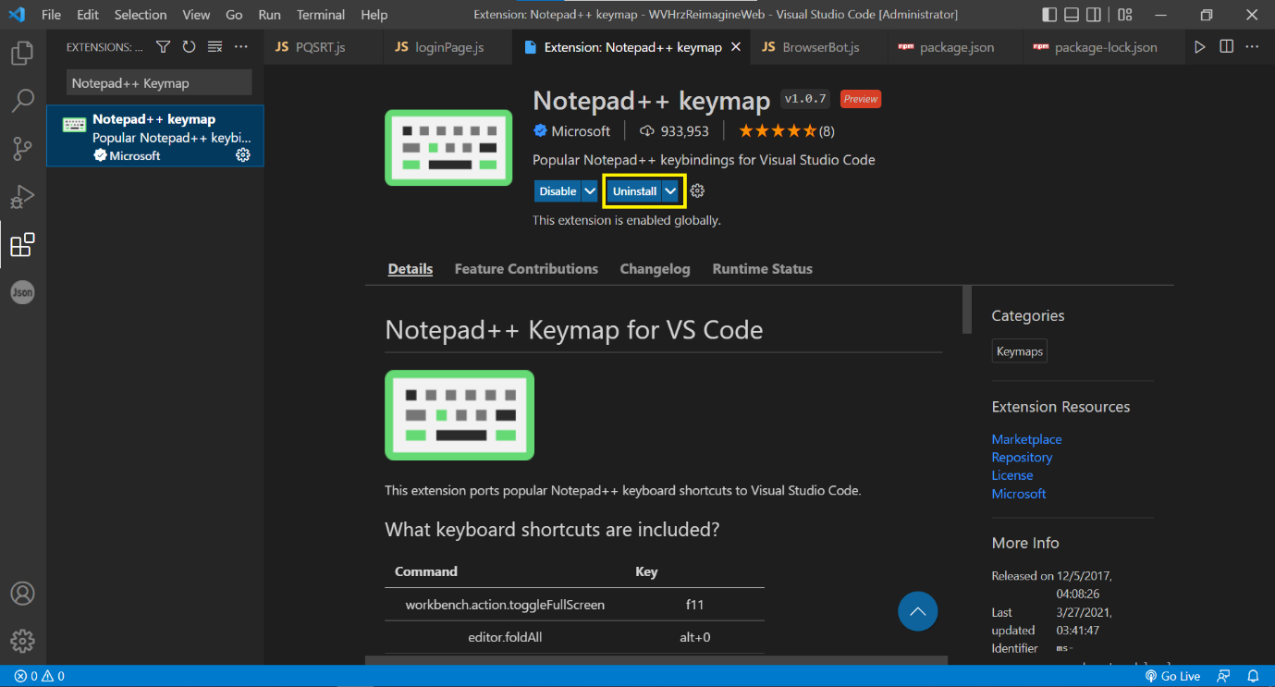

**Command 🡪 Key**

Editor.foldAll 🡪 alt+0

Editor.unfold 🡪 shift+alt+0

